Ideation Phase
Define the Problem Statements

Date | 31 January 2025
Team ID
Project Name
Maximum Marks | 2 Marks

Customer Problem Statement Template:
The Customer Problem Statement helps the project team understand the problem from the user's perspective. In this project, it is used to identify the difficulties that healthcare professionals and researchers face when working with heart disease data. Since healthcare datasets are often large and complex, analyzing them and finding useful insights can be challenging.
By clearly defining the customer problem, the team can focus on finding a practical solution for analyzing heart disease data and identifying key risk factors. Understanding the users’ needs also helps in designing useful tools such as interactive dashboards and visualizations that make the data easier to understand. This approach allows the team to create a solution that supports better healthcare analysis and improves decision making.
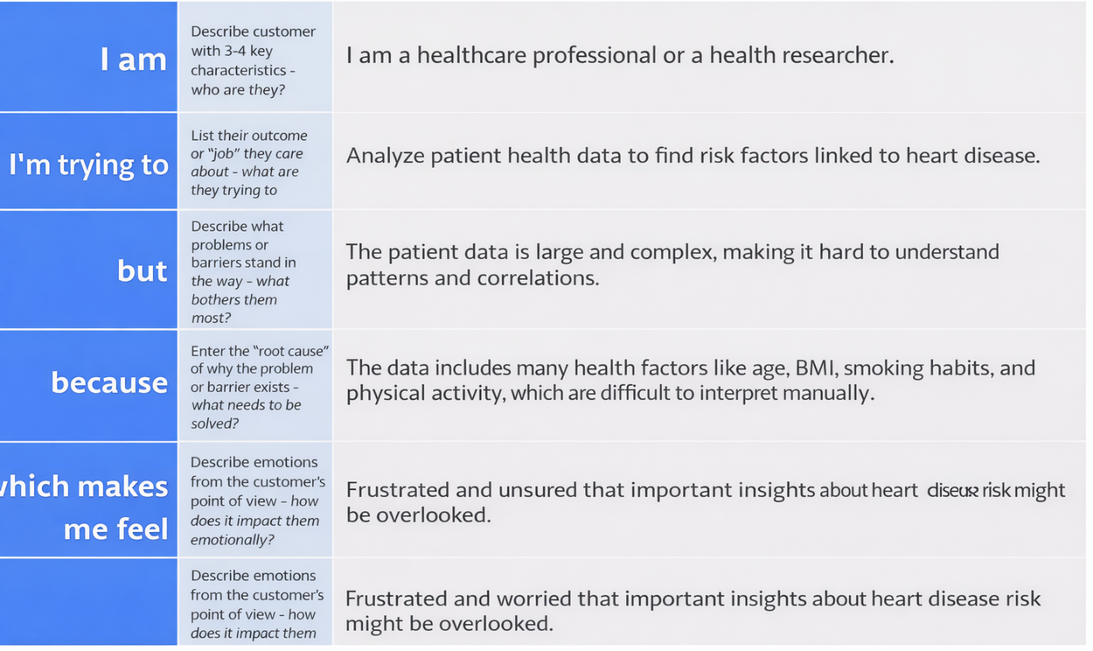
Reference: https://miro.com/templates/customer-problem-statement/
Example: 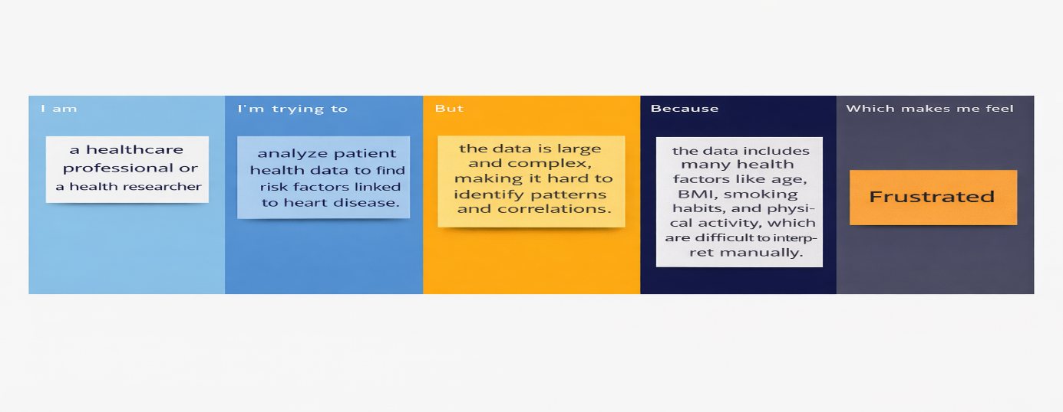

Problem Statement (PS) | I am (Customer) | I’m trying to | But | Because | Which makes me feel
PS-1 | I am a healthcare professional working in a hospital. | analyze patient health data to identify people who are at risk of heart disease | the patient data is large and complex | the data contains many factors like age, BMI, smoking habits, alcohol use and physical activity which are difficult to analyze manually | frustrated because it is hard to identify important risk patterns
PS-2 | I am a health researcher studying cardiovascular diseases. | understand how lifestyle habits affect heart disease risk | the available data is difficult to interpret clearly | traditional reports and spreadsheets do not show relationships between health indicators effectively | worried that important insights about heart disease risk may be missed

